Assessment Total marks: 100

The Task Manager Single Page Application allows you to manage task and set their priorities in range of 0 to 10. Each task will have description, priority, start date and end date.
Use WPF to develop UI (refer to images below). Below are the features of Task Manager:
- Add /View Task. Data should be saved in MSSQL database 50 marks
- On view task screen: 50 marks
  - User can search task by task name, start date, end date and priority.
    - Start date and end date, both should be future dates
    - End date should not be same or less than start date.

Wireframes

Add Task
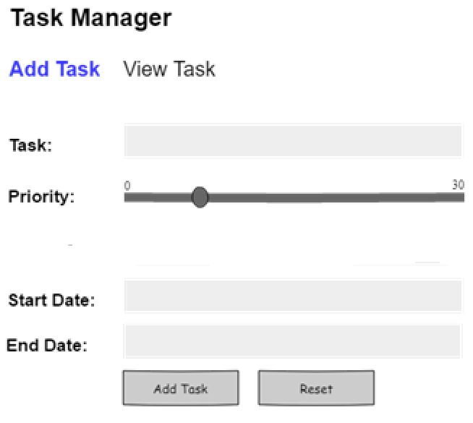

View Task
